**UserDefineVehicleRequestMove Model Description**

This model is going to show how to request a vehicle move to a transfernode and part there without a modelentity. By using this, you can achieve request the vehicle ahead of time.

Below is the data table in this model. You can see there are three determine columns which are used to indicate which transfernode the vehicle should move to.

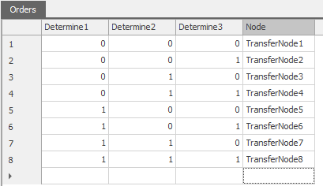

For the vehicle object, Under the ‘Data’ category, you can see three input variables. As shown below, the matching logic is Iuput1 – Determin1; Input2 – Determin2; Input3 – Determine3. Based on the inputs in the figure, the vehicle should move to TransferNode7

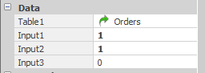

When you run the model, after clicking the button “Move” above the vehicle, you will see the vehicle move to TransferNode7 and then park there.